Creating Snapshot in UCD on top of what is deployed to L.Z & running deployment to subsequent NEEDY environments.

1. Go to UCD Web & traverse to your application

<https://ucd.intranet.group/#application/865cc0af-2f37-4dd6-aa37-25816de1053f>

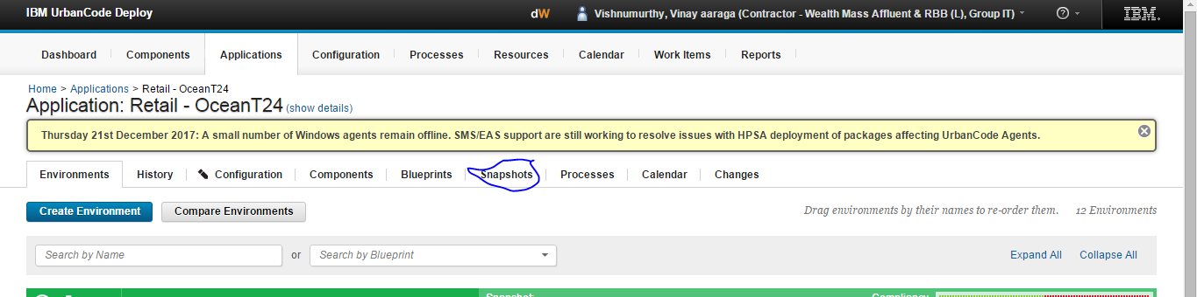

1. Go to ‘Snapshot’ section & hit create snapshot & give relevant description and – version number & date – to follow naming convention

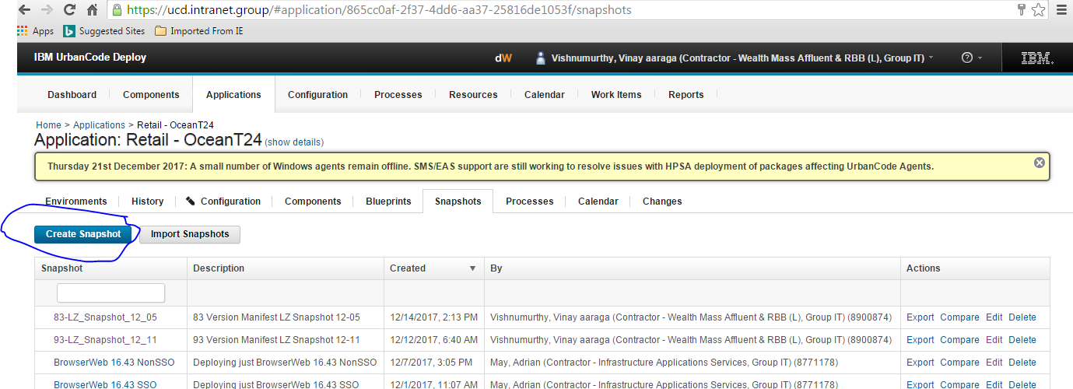

1. Select as below

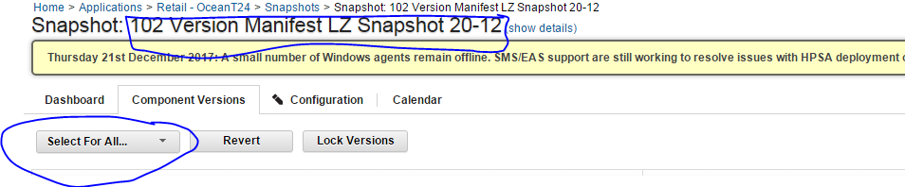

Under Select For All drop down – pick up ‘Copy from Environment’

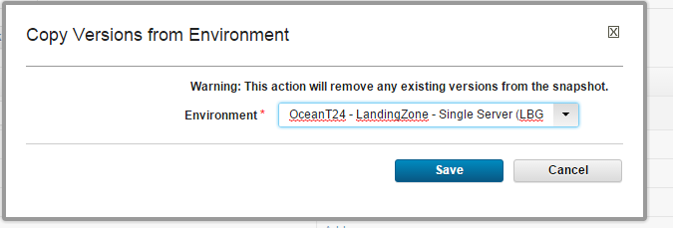

1. Choose needy version.

It will highlight latest shapshot available version in UC ‘Code station’ – which we can pick up

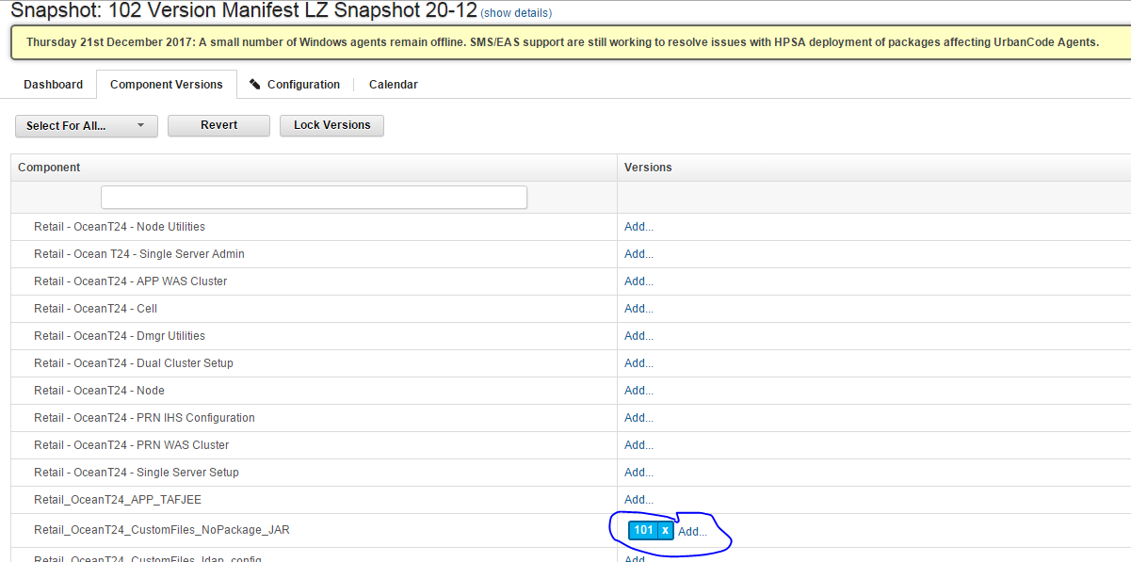

1. Goto created snapshot link

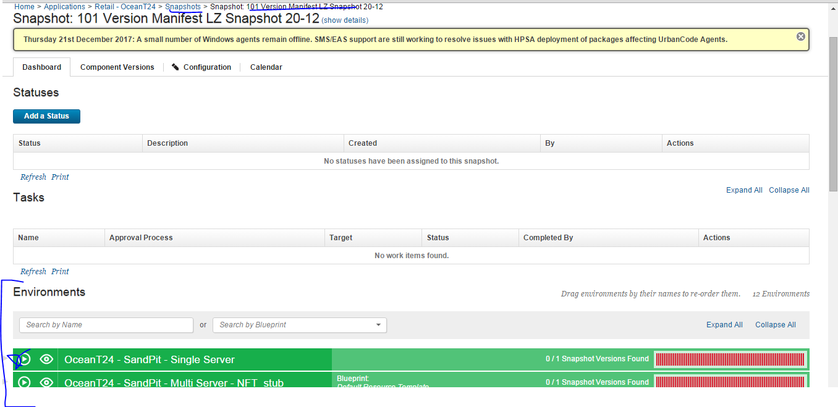

1. Click ‘Process Request’ Play button ☺ against REQUIRED enironemnt

cid:image007.png@01D37A5F.64699840

1. Uncheck first option & select process name which you want to run from dropdown

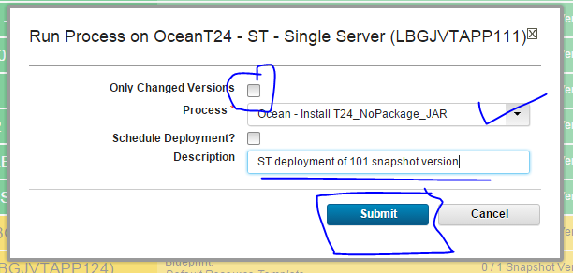

1. You can verify results once you hit submit – in log viewer window. Eg log line is as per below

[copy] Copying /opt/urbancode/ibm-ucdagent/var/work/Retail_OceanT24_CustomFiles_NoPackage_JAR/T24_NoPackage.jar to /t24/app/loclib/T24_NoPackage.jar